|  |
| --- |
| Resource Allocation System |
| User Manual |
| This document will guide the user in using Resource Allocation System. It contains details about actions that user will perform in this application. |

11/7/2014

Table of Content

Resource Allocation System 0

1.0 General Information 3

1.1 System Overview 3

1.2 Organization of the manual 3

2.0 System Summary 4

2.1 System Configuration 4

2.2 User Access Levels 4

2.3 Contingencies 4

3.0 Getting Started 5

3.1 Logging In 5

3.2 System Menu 5

3.2.1 Timetable Menu 5

3.2.1.1 **Timetable** > **New** 6

3.2.1.2 **Timetable** > **Calendar View** 6

3.2.1.3 **Timetable** > **Open Timetable** 7

3.2.2 Resources Menu 7

3.2.2.1 **Resources** > **Building** 8

3.2.2.2 **Resources** > **Classrooms** 9

3.2.2.3 **Resources** > **Classroom Availability** 10

3.2.2.4 **Resources** > **Programs** 12

3.2.2.5 **Resources** > **Program Cycles** 12

3.2.2.7 **Resources** > **Area** 14

3.2.2.8 **Resources** > **Subjects** 15

3.2.2.8 **Resources** > **Timeslots** 17

3.2.2.9 **Resources** > **Teachers** 17

3.2.2.10 **Resources** > **Teacher Availability** 18

3.2.2.11 **Resources** > **Manage Holidays** 19

3.2.2.11 **Resources** > **Teacher Activity** 20

3.2.3 Change Password 21

3.2.4 Logout 21

1.0 General Information

This section explains in general terms the system and the purpose for which it is intended.

* 1. System Overview

RAS application is a graphical user interface that will allow users to easily generate the required timetable for all their ongoing programs of a university. This application allows users to allocate the resources i.e. professors to different subjects and sessions of a program in some predefined weeks of a given year keeping the constraints like holidays, types of classrooms, professor availability, class timings etc. in mind.

1.2 Organization of the manual

This manual is organized in two sections excluding this one for now - System Summary and Getting Started. System Summary sections describes about the system configuration, user access levels and any contingencies while Getting started section contains complete reference to the application. It contains details about all functionality of the system.

2.0 System Summary

This section provides a general overview of the system. The summary outlines the uses of the system’s hardware and software requirements, system’s configuration, user access levels and system’s behavior in case of any contingencies.

2.1 System Configuration

2.2 User Access Levels

Everyone can use application, but only registered users are able to save data to database.

2.3 Contingencies

In case of power outage data are not saved in internal memory of the operating device (except photos that are stored in external storage folder of the device). In case there is no Internet connection available data cannot be saved in internal memory of the operating device.

3.0 Getting Started

This section explains how to access the Resource Allocation System and presents briefly system menu.

3.1 Logging In

Depending upon the different user roles present in the system, users can login to the application by providing their respective user name and password information on the login page.

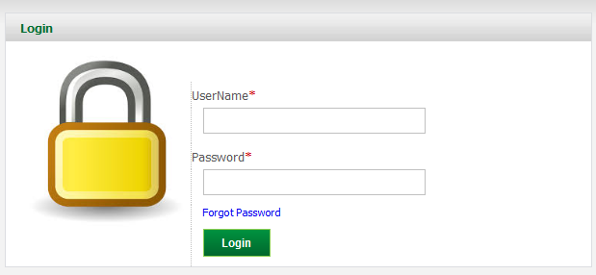

In case a user forgets the password, he can retrieve it with the “**Forgot Password**” which will ask for user’s registered Email and send the password on that Email address.

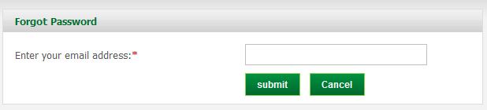

3.2 System Menu

As of the current release, Resource Allocation System contains four main menus, which further have sub menus.

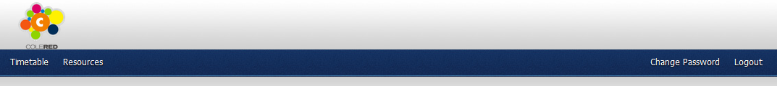

3.2.1 Timetable Menu

This menu item provides the functionality to manage a timetable. Direct links to sub menus **“New”, “Calendar View”, “Open Timetable”** are also given as buttons on Timetable Dashboard which gets visible when a user clicks on “**Timetable”**.

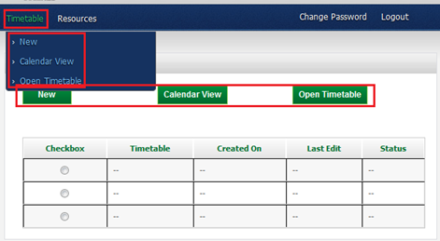

3.2.1.1 **Timetable** > **New**

This option lets a user to create new timetable by providing a name for it and the duration for which timetable needs to be generated.

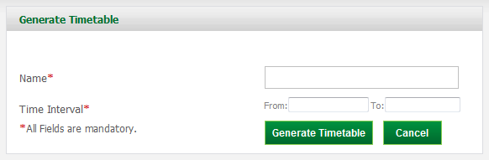

Once the **“Generate Timetable”** button is clicked, a timetable gets generated and is displayed in tabular format as follows-

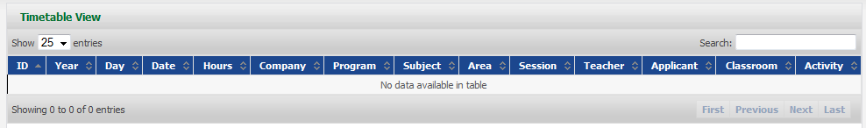

3.2.1.2 **Timetable** > **Calendar View**

To view the timetable in calendar view, use this option. It will show the timetable in a Calendar unlike the tabular view.

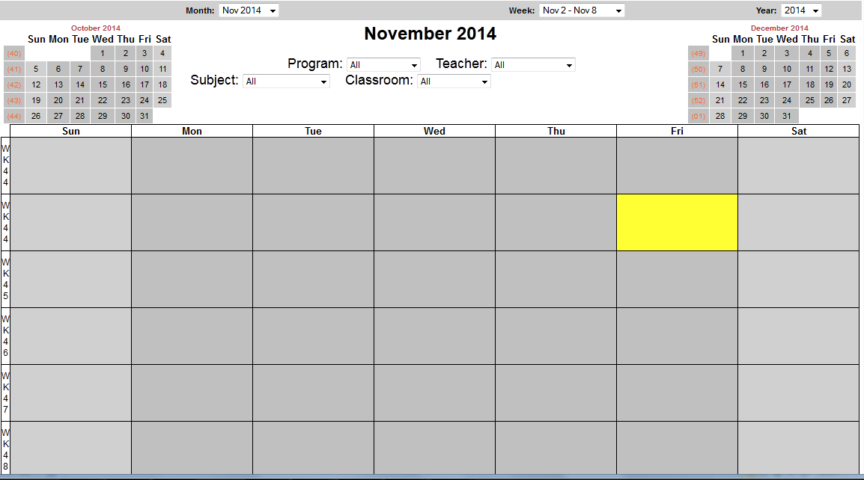

3.2.1.3 **Timetable** > **Open Timetable**

This option will open the recent timetable in tabular format, in a new tab.



3.2.2 Resources Menu

All the prerequisites required to generate a timetable can be managed from here. This menu provides options to manage all the resources like teachers, programs, subjects, sessions, classrooms etc.

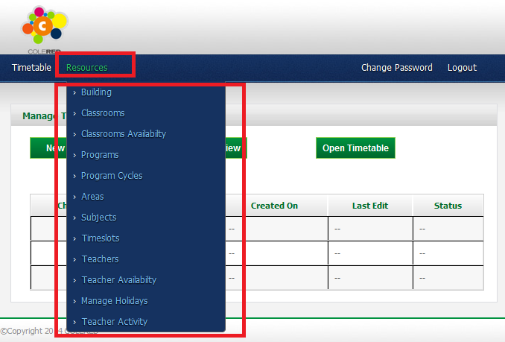

3.2.2.1 **Resources** > **Building**

Using this option, you can manage the buildings. To go to the building dashboard page which shows a list of all buildings in the system and all actions that can be performed on these building, go to **Resources -> Building**

To add a building, click on **“Add New”** link on the right hand side of Building Dashboard.

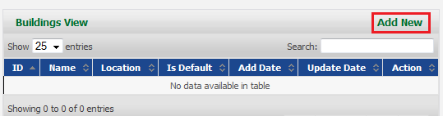

This will open a page as below where Building information can be provided.

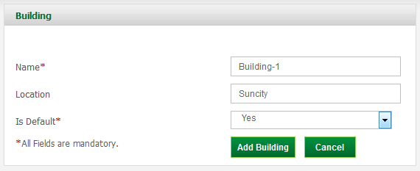

After the building has been added, it will appear on the dashboard as below-

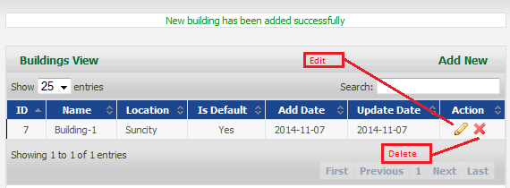

You can click on the **Edit** link to edit the details of building and you can also delete the building by clicking on cross sign next to edit link.

3.2.2.2 **Resources** > **Classrooms**

Using this option, you can manage the classrooms. To go to the classroom dashboard page which shows a list of all classrooms in the system and all actions that can be performed on these classrooms, go to **Resources -> Classrooms**

To add a classroom, click on **“Add New”** link on the right hand side of Classroom Dashboard.

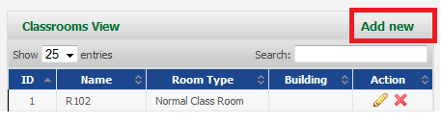

This will open a page as below where Classroom information can be provided.

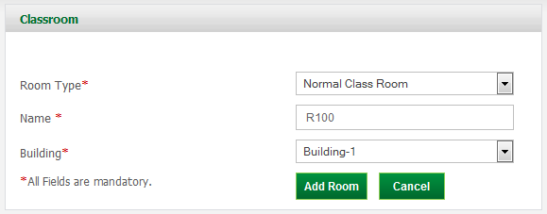

After the classroom has been added, it will appear on the dashboard as below-

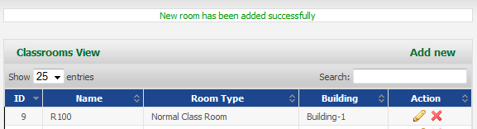

You can click on the **Edit** link to edit the details of classroom and you can also delete the classroom by clicking on cross sign next to edit link.

3.2.2.3 **Resources** > **Classroom Availability**

Using this option, you can manage the classrooms availability. To go to its dashboard page which shows a list of all classrooms which are available in the system and actions which can be performed over them, go to **Resources -> Classrooms Availability**

To add a classroom, click on **“Add New”** link on the right hand side of the Dashboard.

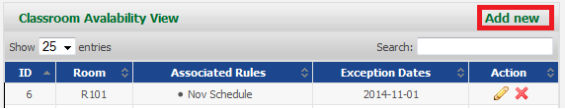

This will open a page as below where Classroom Availability can be provided.

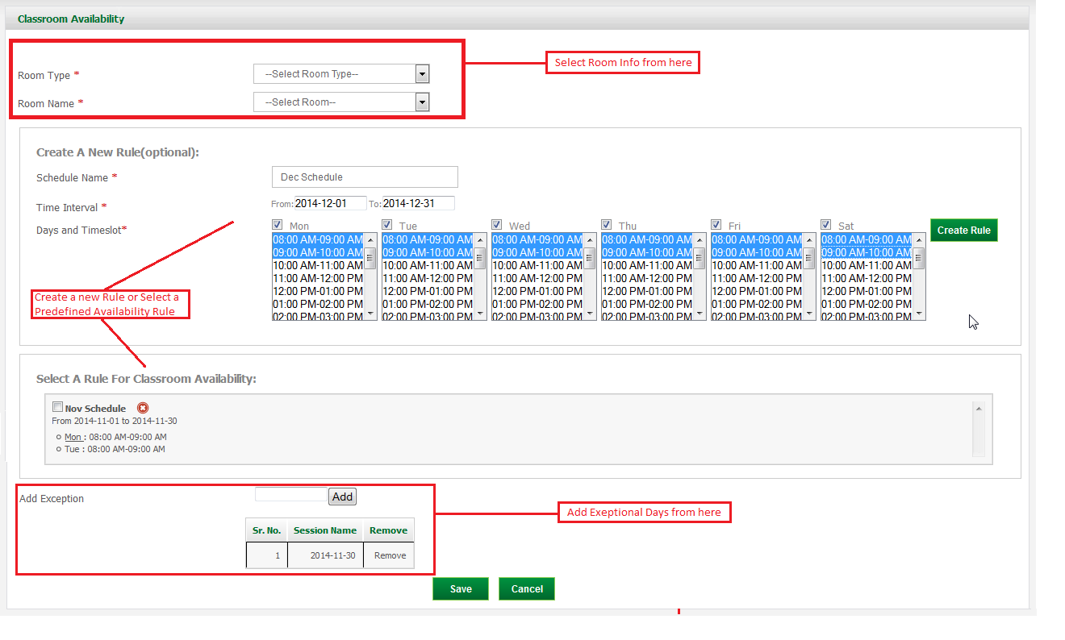

After the classroom availability has been added, it will appear on the dashboard as below-

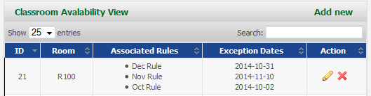

You can click on the **Edit** link to change the classroom availability or you can also delete the classroom availability by clicking on cross sign next to edit link.

3.2.2.4 **Resources** > **Programs**

Using this option, you can manage the programs. To go to its dashboard page which shows a list of all programs in the university and all actions that can be performed on these programs, go to **Resources -> Programs.**

To add a program, click on **“Add New”** link on the right hand side of Program Dashboard.

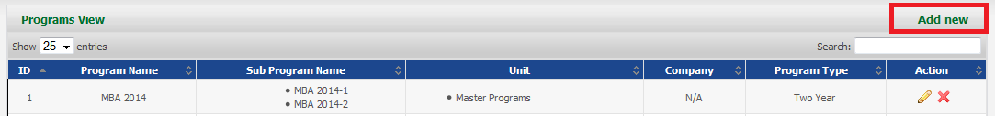

This will open a page as below where Program details can be provided.

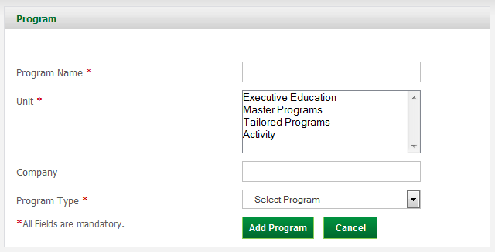

After the program has been added, it will appear on the dashboard as below-

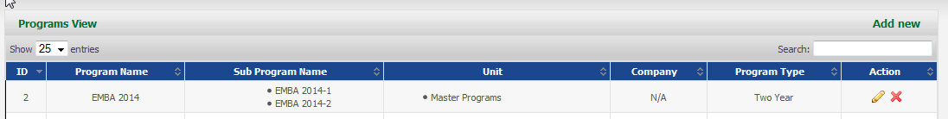

You can click on the **Edit** link to change the Program details or you can also delete the Program by clicking on cross sign next to edit link.

3.2.2.5 **Resources** > **Program Cycles**

Using this option, you can manage the Program Cycles. To go to the Program Cycles dashboard page which shows a list of Programs and its associated Cycles and all actions that can be performed on these Program Cycles, go to **Resources -> Program Cycles**

To add Program Cycles, click on **“Add New”** link on the right hand side of Program Cycles Dashboard.

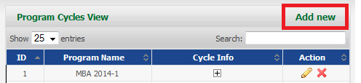

This will open a page as below where Program Cycles details can be provided.

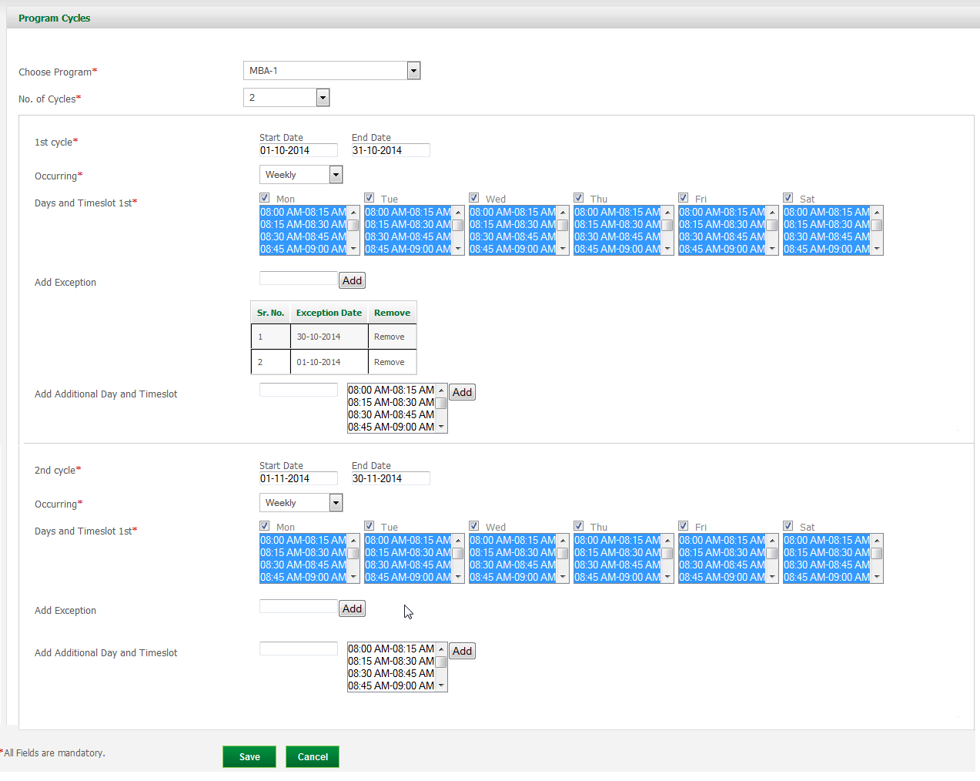

After the Program Cycles has been added, it will appear on the dashboard as belo You can click on the **Edit** link to change the Program Cycles details or you can also delete the Program Cycles by clicking on cross sign next to edit link.

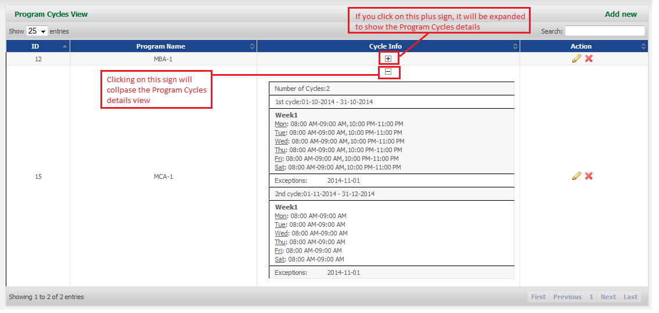

You can click on the **Edit** link to change the Program Cycles details or you can also delete the Program Cycles by clicking on cross sign next to edit link.

3.2.2.7 **Resources** > **Area**

Using this option, you can manage the Areas. To go to the Areas dashboard page which shows list of all Areas and the actions that can be performed on these Areas, go to **Resources -> Areas.**

To add an Area, click on **“Add New”** link on the right hand side of Areas Dashboard.

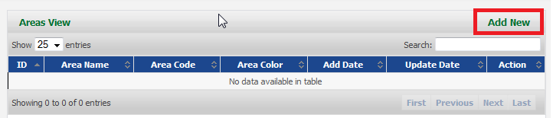

This will open a page as below where Area details can be provided.

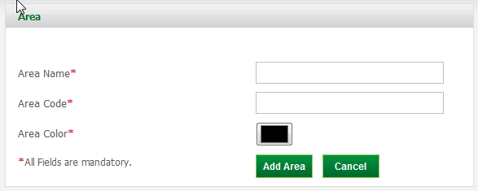

After the Area has been added, it will appear on the dashboard as below-

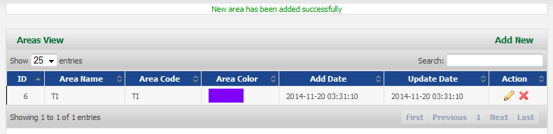

You can click on the **Edit** link to change the Area details or you can also delete an Area by clicking on cross sign next to edit link.

3.2.2.8 **Resources** > **Subjects**

Using this option, you can manage the Subjects and their Sessions. To go to its dashboard page which shows list of all Subjects and their associated sessions, go to **Resources -> Subjects**

To add a Subject, click on **“Add New”** link on the right hand side of Subjects Dashboard.

A Session can only be created when its Subject has been added.

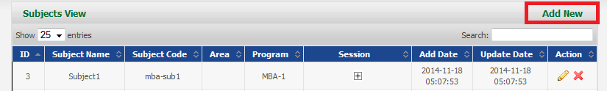

This will open a page as below where Subject details can be provided.

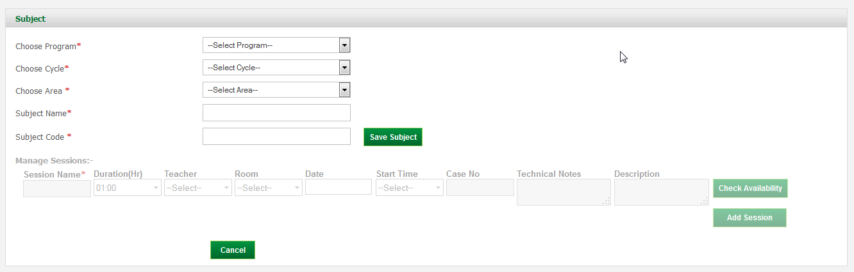

**“Save Subject”** will add the Subject and “**Manage Sessions**” section will get enabled. Now, sessions corresponding to this section can be added.

“**Session Name**”, “**Duration**” and “**Teacher**” fields will be mandatory for creating **Unscheduled**/**Unreserved** Activities.

Whereas, to create a **Scheduled**/**Reserved** Activity, user will have to provide the “**Room**”, “**Date**” and “**Start Time**” details. Thereafter, session will be added depending upon the Teacher/Classroom availability on that day/timeslot.

All Reserved/Unreserved activities can also be seen in **Resources** -> **Teacher Activity** View.

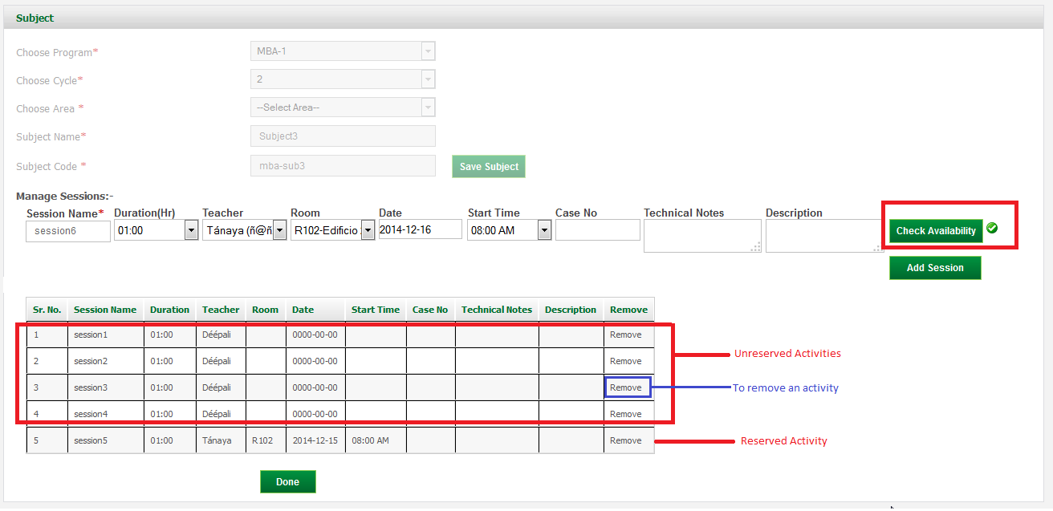

After the Subject/Sessions have been added, it will appear on the dashboard as below-

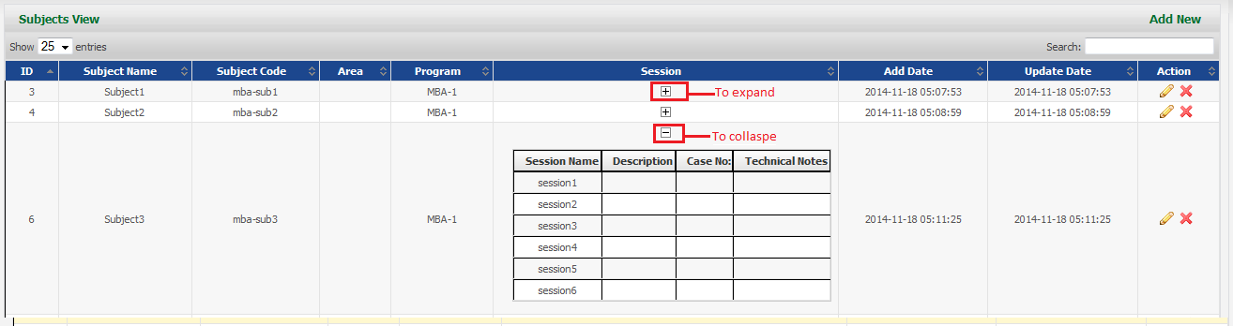

You can click on the **Edit** link to add more Sessions or you can delete the Subjects and their corresponding sessions by clicking on cross sign next to edit link.

3.2.2.8 **Resources** > **Timeslots**

Using this option, you can only View the Timeslots. To go to its dashboard page which shows list of all Timeslots in the system, go to **Resources -> Timeslots.** This will show the dashboard as below-

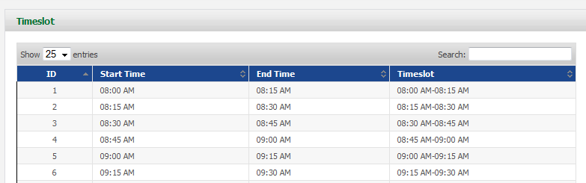

3.2.2.9 **Resources** > **Teachers**

Using this option, you can manage the Teachers. To go to its dashboard page which shows list of all Teachers and the actions that can be performed on these Teachers, go to **Resources -> Teachers.**

To add a Teacher, click on **“Add New”** link on the right hand side of Teacher Dashboard.

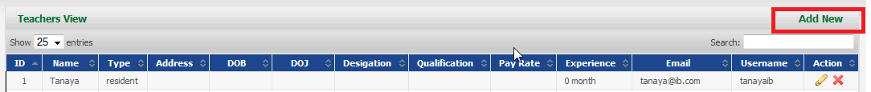

This will open a page as below where Teacher details can be provided.

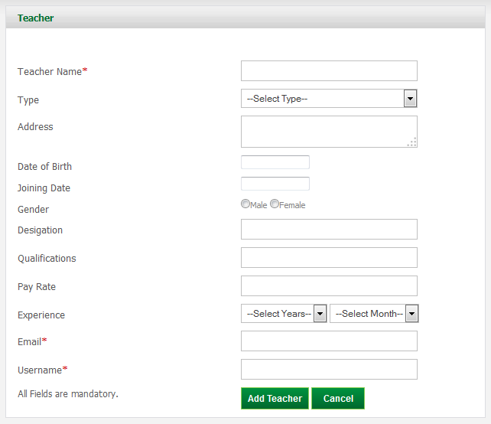

After the Teacher has been added, it will appear on the dashboard as below-

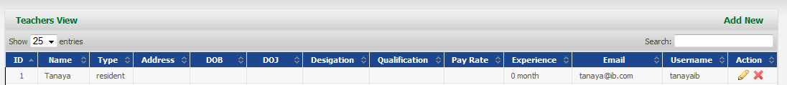

You can click on the **Edit** link to change the Teacher details or you can also delete the Teacher by clicking on cross sign next to edit link. But, it should be noted that, **Email ID** and **Username** cannot be edited.

3.2.2.10 **Resources** > **Teacher Availability**

Using this option, you can manage the Teacher Availability. To go to its dashboard page which shows the availability of Teachers and the actions that can be performed on these Subjects, go to **Resources -> Teacher Availability.**

To add a Teacher Availability, click on **“Add New”** link on the right hand side of Teacher Availability Dashboard.

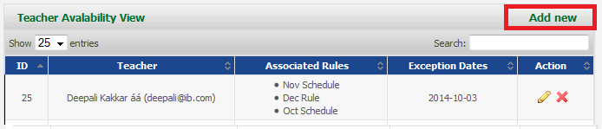

This will open a page as below where Areas details can be provided.

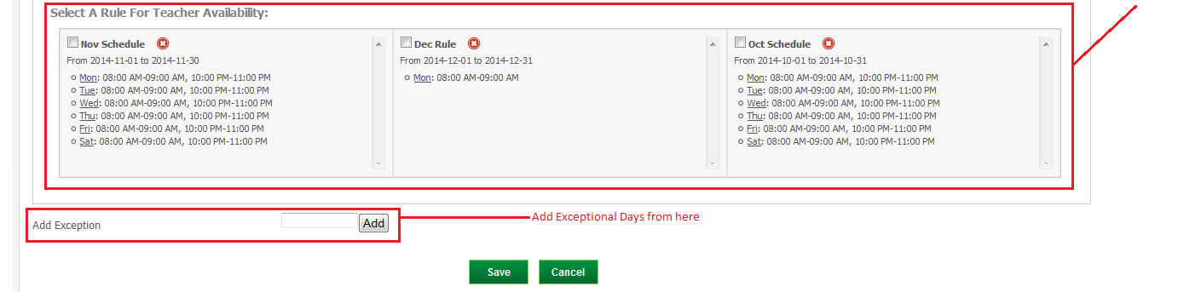

After the Teacher Availability has been added, it will appear on the dashboard as below-

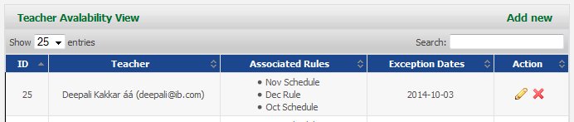

You can click on the **Edit** link to change the Teacher Availability details or you can also delete the Teacher Availability by clicking on cross sign next to edit link.

3.2.2.11 **Resources** > **Manage Holidays**

Using this option, you can manage the Holidays. To go to its dashboard page which shows list of all Holidays and the actions that can be performed on these Holidays, go to **Resources -> Manage Holidays.**

To add a Holiday, click on **“Add New”** link on the right hand side of Holidays Dashboard

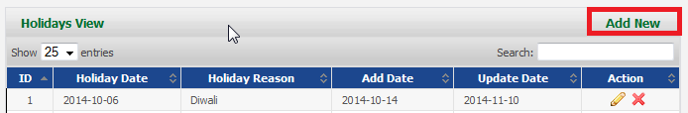

This will open a page as below where Holidays details can be provided.

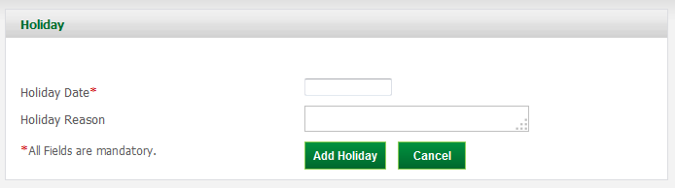

After the Holiday has been added, it will appear on the dashboard as below-

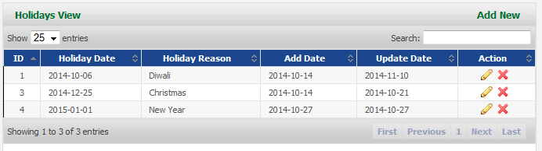

You can click on the **Edit** link to change the Holiday details or you can also delete the Holiday by clicking on cross sign next to edit link.

3.2.2.11 **Resources** > **Teacher Activity**

All activities, Reserved or Unreserved, which are created during Session Management, are displayed here. But they are managed from **Subject** View only. To view Teacher Activity dashboard, go to **Resources -> Teacher Activity.** It will list all the activities as below-

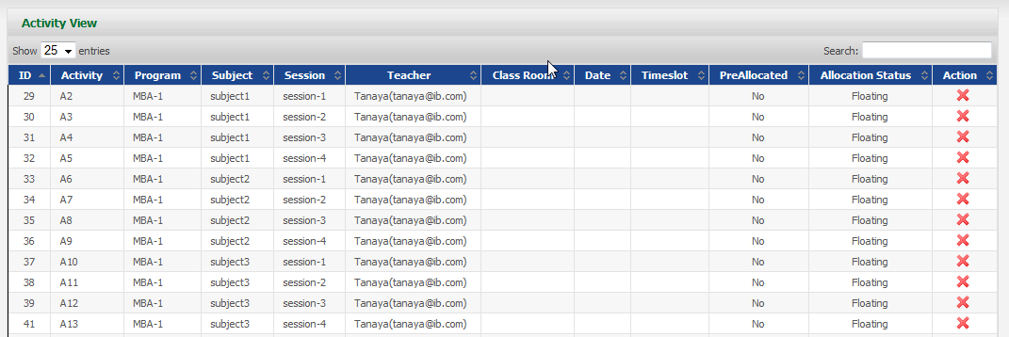

3.2.3 Change Password

This option provides user with the facility of changing their password.

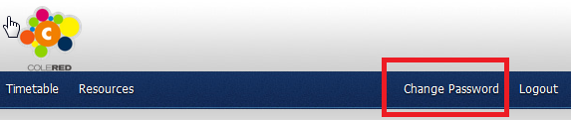

User will be asked for Old and New password.

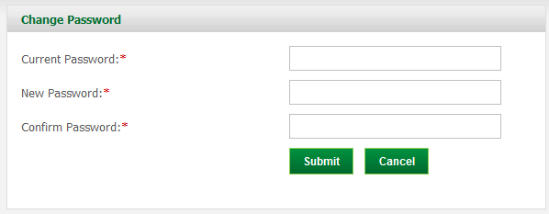

Once the password has been changed, user can login with new credentials.

3.2.4 Logout

To logout of the system, user can click on Logout link on any page.

